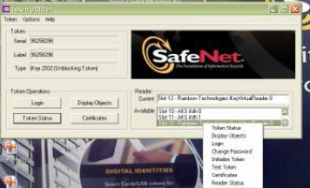

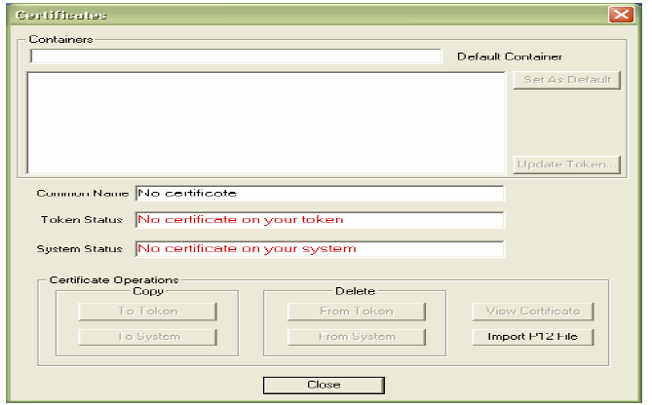

(C) Browse and select the certificate stored on your system and click OPEN.

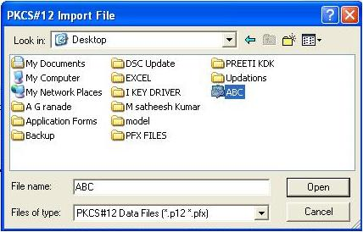

(d) Enter the Password of .PFX file and click OK.

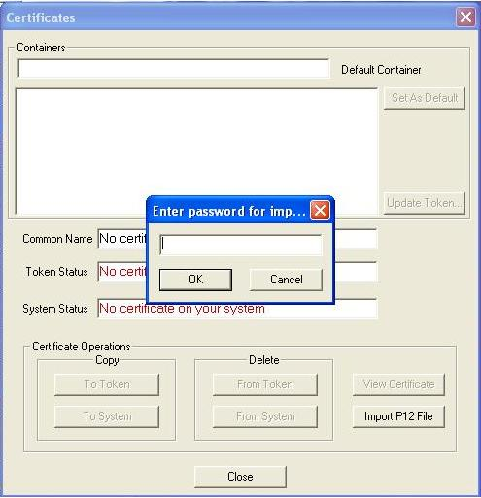

(e) You can see your certificate in default container. If you want to rename it, just right click on it and choose rename, otherwise click OK. Click YES to import the Certificate Chain.

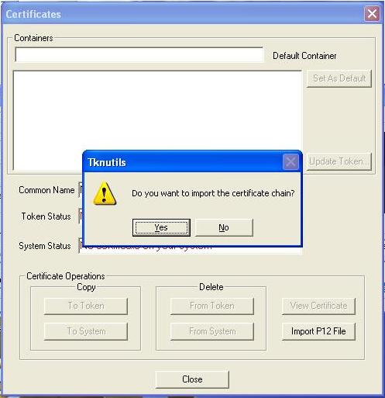

( F ) A confirmation message is displayed if Import is Successful. Click OK.

